Name________________________________________
Place an X in the box below to indicate your Science Class

09SCI  B1 | 09SCI  B2 | 09SCI  B3 | 09SCI  G1 | 09SCI  G2 | 09SCI  G3


ST ALOYSIUS’ COLLEGE

2017

Semester 2 Examination

Year 9 Science- MODIFIED FOR 2018 REVISION

General Instructions  - Reading time – 5 minutes  - Working time – 1 ½ hours  - Write using black or blue pen  - Write your name and  Science class at the top of each Section  - Do not detach any pages  - Hand in each part separately  - Show all working, as marks may be awarded for relevant working | SECTION I (25 marks)  Multiple Choice Questions  - Answer in the separate Multiple Choice Answer Sheet  SECTION II (85 marks)  Part A, Part B, Part C and Part D  Short Answer Questions  Answer in the space provided after each question
Section I: 25 Multiple Choice Questions

Answer these questions on the provided answer sheet.

- While undergoing major surgery, patients are anaesthetised so they don’t feel any pain. The anaesthetic is often administered as a gas through a facemask that covers the nose and mouth.

Identify the human systems involved in the action of anaesthetic gases

- Digestive system and Nervous system
- Digestive system and Respiratory system
- Nervous system and Respiratory system
- Digestive system, Nervous system and Respiratory system

- The thermometer below shows the body temperature of three students.

Which line in the table below indicates the relationship between the body temperature of each student and their health?

- Which of the following is a reflex response?

- Reading
- Blinking
- Tying your shoelaces
- Writing.

- The airway surface liquid (ASL), often referred to as mucus, is a thin layer of fluid covering the surface of airways. The major function of mucus is to protect the lung by trapping foreign particles, bacteria and chemicals entering the lung. The mucus is comprised of water, ions, and various kinds of macromolecules some of which possess the protective functions such as anti-microbial (inhibits the growth of microorganisms). The mucus is part of the:

- First line of defence
- Second line of defence
- Third line of defence
- Fourth line of defence

- A chemical substance is secreted into the bloodstream by the adrenal glands in our body. It acts as a chemical messenger involved in coordination.

What term best describes this substance?

- Antibody
- Hormone
- Inorganic
- White blood cell

- The human body monitors the amount of water in the blood. When there is too little water, a message is sent to the pituitary gland causing the release of antidiuretic hormone (ADH). ADH causes the kidneys to re-absorb water from the urine so that the blood water level returns to the normal range.

This is an example of:

- a negative feedback loop contributing to homeostasis
- a positive feedback loop contributing to homeostasis
- a negative feedback loop leading to a failure of homeostasis
- a positive feedback loop leading to a failure of homeostasis

- A survey found that in one town, half of the population had diabetes.
Of those who had diabetes, 14% had Type 1 diabetes, 80% had Type 2 diabetes and 6% did not know what type of diabetes they had.

Which graph correctly shows the information for the WHOLE town?

- A student notices that when he has been startled by a loud noise his heart beats faster and his breathing rate rises. Being a good Year 9 Science student, he also suspects that:

- the level of adrenaline in his blood has fallen
- the level of glucose in his blood has fallen
- the level of adrenaline in his blood has risen
- he needs a more nutritious diet

- Which of the following is not an infectious disease?
- Polio
- Measles
- Diabetes
- Whooping cough

- Proteins molecules produced by the human body to immobilise pathogens are called

- Antibodies
- Mast cells.
- Antigens.
- Immunogens

- Calculate the percentage of deaths caused by infectious diseases worldwide and in low-income countries and then identify the correct statement.

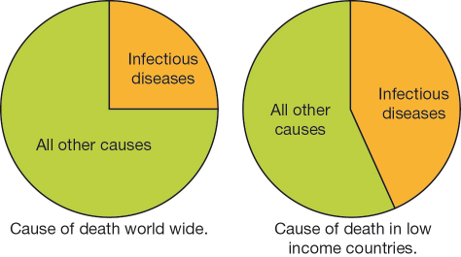

- Infectious diseases cause twice as many deaths in low-income countries compared to the rest of the world.
- Less than a quarter of the deaths worldwide are caused by infectious diseases.
- 45% of deaths in low-income countries are caused by infectious diseases.
- 85% of deaths in the world have a cause other than an infectious disease

- The diagram shows a chemical compound. What is the formula of the compound?

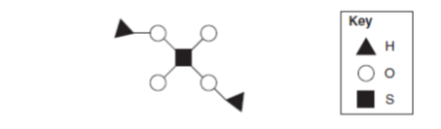

- S₂OH
- H₄OS₂
- H₂SO₄
- OH₂S₄

- The element that is present in both hydrochloric acid and sulfuric acid is:

- hydrogen
- halogen
- hydroxide
- helium

- Bases:

- unlike dangerous acids, are generally quite safe
- are just a stronger type of acid
- are found in citrus fruits
- are used in many cleaning products

- Adding liquid X to water decreases its pH. This shows that the liquid X is:

- an acid.
- a base.
- neutral.
- water.

- A pH meter can be used to show the pH of a substance, which is displayed digitally on the screen. Which statement is the most correct?
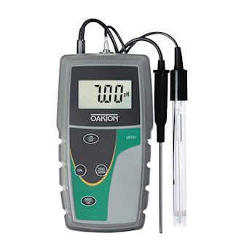

- Using a pH meter is a more reliable way to measure the pH of a solution than using universal indicator.
- Using a pH meter is a more valid way to measure the pH of a solution than using universal indicator.
- Using a pH meter rather than universal indicator is the only way for measurements to be made in a fair way
- Using a pH meter is a more accurate way to measure the pH of a solution than using universal indicator.

- What does X represent in this equation?

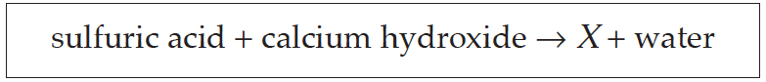

- Carbon dioxide
- Calcium sulfate
- Hydrogen gas
- Sulfuric hydroxide

- What is the name of the type of chemical reaction in Question 17?

- Neutralisation
- Combustion
- Corrosion
- Decomposition

- A student was studying chemicals found in the kitchen and noted that tea and coffee are both clear brown fluids. If lemon juice is added to both, the tea turns an orange colour but the coffee does not.

Based on these results, which conclusion is correct?

- Tea acts as an indicator.
- Coffee acts as an indicator.
- Both tea and coffee act as indicators.
- Neither tea nor coffee acts as an indicator.

- The strongest acid from the following acids is:

- carbonic
- hydrochloric
- acetic
- citric

